|  |
| --- |
| **ECR App** |
| **Version History**   |  |  |  |  | | --- | --- | --- | --- | | Date | Version | Author | Changes | | 11/09/2020 | 1 | L Boonekamp | Initial | |  |  |  |  | |

Contents

How to access the ECR App 3

How to create an ECR request 3

General Processing Rules 4

Tasks 5

Accessing your tasks 5

Completing a Task 6

Group Engineering Manager – Choosing Reviewers 7

Engineering Leaders – Adding an ECR to an ECN 8

Adding comments and attachments 8

Searching and filtering ECR requests 9

Filters 9

Issues/Requests 10

# How to access the ECR App

The ECR App provides employees with a way to enter Engineering Change requests.

Open <https://apps.temperzone.com/ecr> in a Google Chrome or Chrome Mobile.

To access you will be asked to authenticate using your email address and password. This will mean that you will get a phone call or message from your Authenticator app and will need to take the appropriate action.

# How to create an ECR request

Once signed on, click on the ‘**New**’ tab at the top of the screen under the welcome message.



The following page is then displayed.

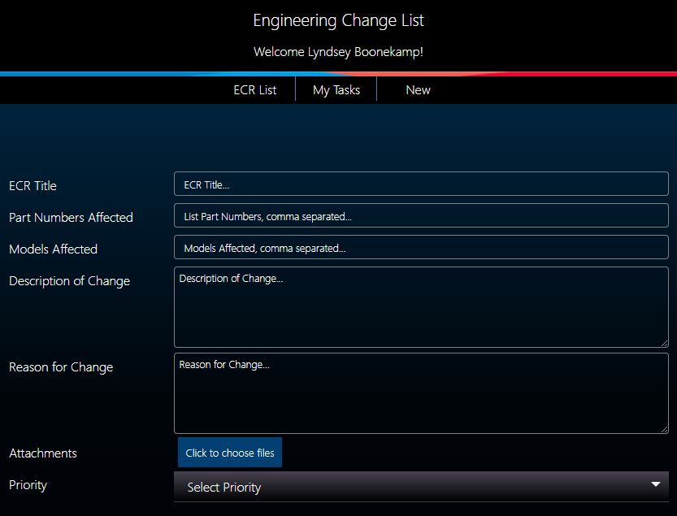

Fill in all fields on the form and choose a Priority.

To submit your request, click the ‘Submit' button at the bottom of the form.

**Note**: If you added attachments to your request, it may take a short while longer to submit as these attachments are uploaded to the Sharepoint folder related to your request.

## General Processing Rules

When you raise an Engineering Change request, the following workflow steps are followed.

The standard approval chain is as follows (in order):

1. A Task is assigned to both Engineering Leaders. If the Engineering Leaders;
2. Approve or reject your request, a task is assigned to the Product Manager
3. Ask for more information, a task is assigned back to you requesting more information.
4. Once the Engineering Leaders have both completed their tasks, a task is assigned to the Product Manager. If the Product Manager;
5. Approves your request. It’s sent back to the Engineering Leaders to be added to an ECN.
6. Rejects your request. It’s closed off and you are notified that your ECR will not be added to an ECN.
7. Decides it needs more investigation. It’s sent on to the Group Engineering Manager who chooses a selection of staff members to review the change.
8. The Group Engineering Manager chooses their reviewers and tasks are assigned to all reviewers. The workflow pauses as it waits for all reviewer tasks to be completed.
9. Reviewers complete their tasks and a task is assigned back to the Group Engineering Manager to make the final decision. If the Group Engineering Manager;
10. Approves your request. It’s sent back to the Engineering Leaders to be added to an ECN.
11. Rejects your request. It’s closed off and you are notified that your ECR will not be added to an ECN.
12. Asks for more information. You’ll be assigned a task requesting more information about your request.
13. If your request hasn’t been rejected, the Engineering Leaders receive a final task to add your ECR to an ECN and update the ECR. Your ECR is closed off and you are notified.

# Tasks

Only users in the approval chain will receive tasks. If you’ve received a task you are either in the approval chain or have been nominated as a reviewer.

## Accessing your tasks

When you’re assigned a Task, you’ll receive an email notification email with a link at the bottom which will take you through to the task.

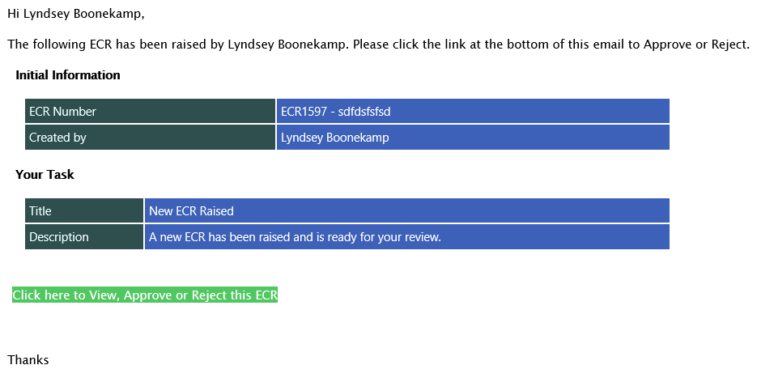

Additionally, you can access your pending tasks from the ‘My Tasks’ button at the top of the home page <https://apps.temperzone.com/ecr>

The task view is shown below.

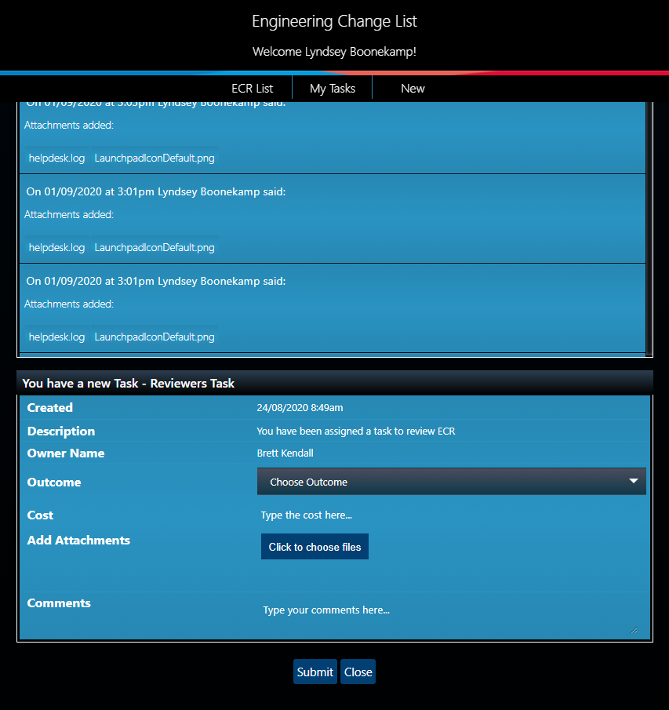

## Completing a Task

By using Approve, Reject or More Information

This method supplies three choices to choose from, each described below.

1. Approved – Approves the request and assigns a task to the next approver in the approval chain.
2. Rejected – Rejects the request and advises the creator. No further tasks are assigned.
3. More Information – Assigns a task back to the creator, requesting more information.

Click ‘Choose Outcome’ to select an Outcome.

### Group Engineering Manager – Choosing Reviewers

When a ECR reaches this stage, a task is assigned to the Group Engineering Manager and a selection of reviewers need to be chosen. The choose reviewers task can be seen below.

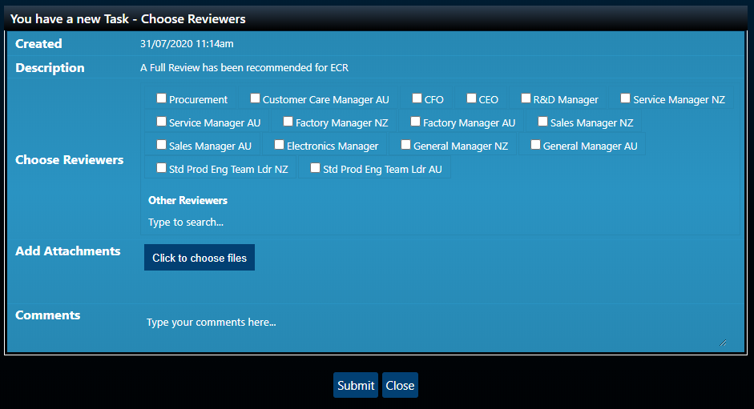

The checkboxes indicate groups in Office 365 that contain staff members who have a job title or role related to the group name. Ticking any of these boxes will include the group in your reviewer selection.

You can also search for an individual staff member by clicking in the box under ‘Other Reviewers’, typing a character and selecting the ‘Tab’ key on the keyboard to initiate the search.

The following dropdown is then displayed.

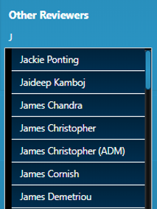

To select a user, click the user’s name.

To perform another search, repeat the steps above.

### Engineering Leaders – Adding an ECR to an ECN

When an ECR reaches this stage, a task is assigned to both Engineering Leaders and the ECR needs to be added to an ECN. The add to ECN task can be seen below.

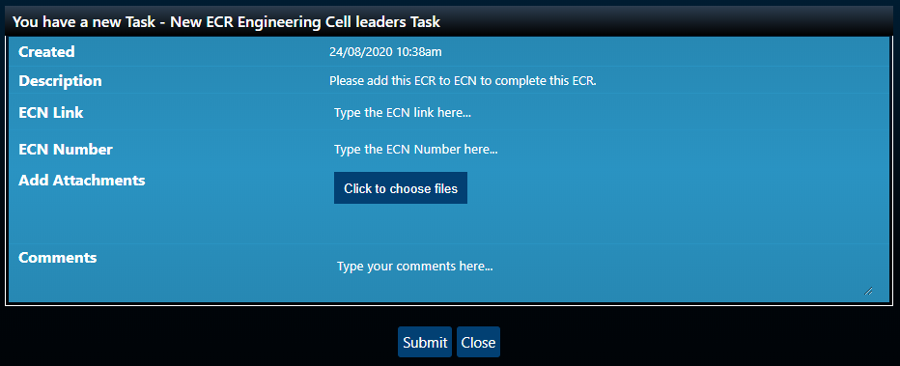

There are two mandatory fields.

1. ECN Link – Specifies a URL to the ECN
2. ECR Number – Specifies the ECN number

To complete the task, fill out the fields and click the ‘Submit’ button.

You can still add comments and attachments.

The ECR is then set to a ‘Completed’ status and the requestor is notified.

### Adding comments and attachments

Adding a comment to your submission

To add a comment to your submission, simply type a comment in the ‘Comments’ box.

Your comment is saved after clicking the ‘Submit’ button.

Adding attachments to your submission

To add attachments to your submission, click the ‘Click to choose files’ button



Select your files from the file window that opens.

The attachments will now be uploaded once you’ve clicked the ‘Submit’ button to submit your task.

# Searching and filtering ECR requests

Searching and filtering allows you to find ECR requests based on a criteria.

To perform a search click the ‘ECR List’ button at the top of the screen under the welcome message.



The following window is displayed.

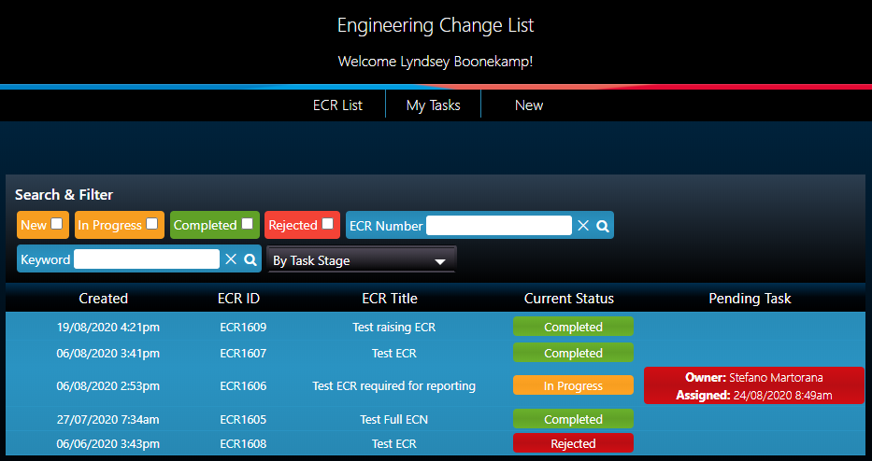

# Filters

There are many different methods of searching.

**By Quick Status**.



To search by quick status select one or more of the checkboxes as seen above.

**By ECR Number**.



Type the ECR Number. Accepted values are ECR1234 or just the numeric portion of the number 1234.

**By Task Stage**.

This method is good if you’re trying to find ECRs at a specific stage.

Click the By Task Stage box. The following dropdown appears.

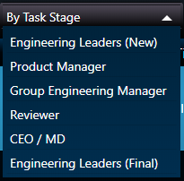

Select one of the stages and your search results are returned.

**By Keyword**. This functionality searches for the given keyword in the following fields; Title, Description Of Change, ECN Number or Reason For Change.



Type a keyword and click the magnifying glass or hit ‘Enter’ on the keyboard.

**Tip**: To clear your search, use the ‘Reset’ button. This will remove all search criteria and filters.

# Issues/Requests

If you have any issues, please remember to send them directly through to the Temperzone IT helpdesk

Email: [helpdesk@temperzone.com](mailto:helpdesk@temperzone.com) or Phone extension 888 in NZ or AU   
Or visit [helpdesk.temperzone.com](http://helpdesk.temperzone.com/)